***Piptadeniastrum africanum* (Fabaceae) unveiling** **anti-stereotypic, anxiolytic, and analgesic effects in sodium valproate-induced autistic disorders in rats**

Authors:

* Ambani Omgba Jeanne Julie1,
* Ngouateu Omer Bébé1,
* Mengue Ngadena Yolande Sandrine1,2,
* Owona Pascal Emmanuel
* Ngang Nguema Franck Emmanuel
* Dzeufiet Djomeni Paul Desiré1

1 Department of Animal Biology and Physiology, Laboratory of Animal Physiology, Faculty of Science, University of Yaoundé 1, P.O. Box 812 Yaoundé, Cameroon

2 Neurosciences axis, Laboratory of Development and Maldevelopment, Department of Psychology, Faculty of Arts, Letters, and Social Science, University of Yaoundé 1, P.O. 755 Yaoundé, Cameroon

@: Corresponding author:

Proposed journal: Brain and Behavior (Wiley and Sons)

|  |  |  |
| --- | --- | --- |
| **NOMS** | **EMAIL** | **ORCID** |
| Ambani Omgba Jeanne Julie | julieomgba3@gmail.com |  |
| Ngouateu Omer Bébé |  |  |
| Mengue Ngadena Yolande Sandrine | [yolsandra89@gmail.com](mailto:yolsandra89@gmail.com) | 0000-0002-1414-4174 |
| Owona Pascal Emmanuel | [emmanuelowina6714@gmail.com](mailto:emmanuelowina6714@gmail.com) | 0000-0002-0233-5299 |
| Ngang Nguema Franck Emmanuel | [ngangnguemaf@gmail.com](mailto:ngangnguemaf@gmail.com) |  |
|  |  |  |
|  |  |  |
| Dzeufiet Djomeni Paul Désiré | [dzeufiet@yahoo.fr](mailto:dzeufiet@yahoo.fr) | 0000-0001-5315-6285 |

**Graphical abstract**

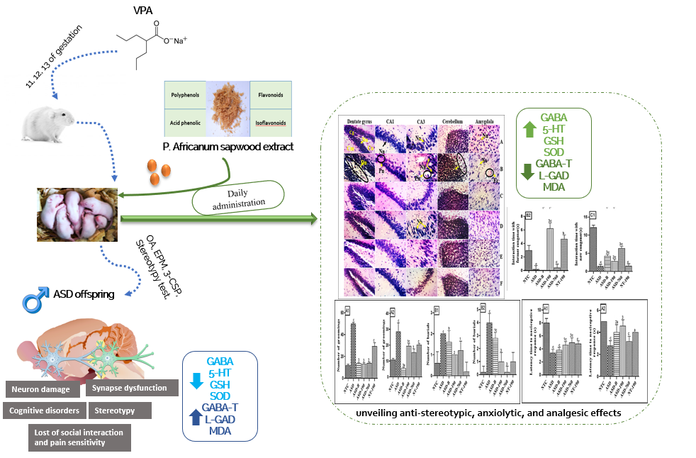

**Abstract**

**Objective:** Individuals who experience Autistic Spectrum Disorders (ASD) present mainly with deficits in communication and social interaction, alongside repetitive behaviors and restricted interests. Often, this disorder is associated with anxiety, nociceptive disorders, and pain. While medical treatment generally focuses on treating the symptoms rather than addressing the underlying causes, traditional medicine is sometimes used as an alternative. *Piptadeniastrum africanum* (*P. africanum*) is used in Cameroonian medicinal folks to treat cognitive disorders. However, its effects and mechanisms of action regarding the inhibition of ASD-like symptoms remain unclear. The primary goal of a recent study was to evaluate the anxiolytic and analgesic effects of the water extract of *P. africanum* on autistic triad induced in rats with sodium valproate.

**Material and Methods:** Thirty-three female rats were bred and separated into two groups once pregnancy was confirmed. One group consisted of six rats given oral distilled water (10 mL/kg), while the other group consisted of 27 rats given sodium valproate (800 mg/kg, p.o.) on days 11, 12, and 13 of gestation. After the rats gave birth, their male offspring were selected for this study once they were three weeks old. The rats were assessed for anxiety, social interaction, and pain sensitivity disorders, and those that displayed these disorders were kept for further experimentation. The rats were then split into six groups of five animals treated with the vehicle, bumetanide, or *P. africanum* extract (190 and 760 mg/kg). Each was subjected to behavioral tests for sociability using the three-chamber social interaction device and the stereotypy device, anxiety using the open arena (OA) and elevated plus maze (EPM), and nociceptive disorders using the hot plate on days 28 and 37 after weaning. At the end of the treatments, the animals were sacrificed under fasting conditions, and some biochemical parameters (markers of GABA metabolism, serotonin, and oxidative status) were assessed in the cerebellum, prefrontal cortex, hippocampus, and amygdala.

**Results:** Findings showed that prenatal administration of sodium valproate induced in male offspring a deficit in social interaction (p<0.001), anxiety disorders (p<0.001), hypersensitivity to pain (p<0.001), increased GABA and serotonin concentration (p<0.001), disturbed oxidative status (p<0.001) and neuronal loss (p<0.001) as well as neuronal disorganization in the hippocampus, cerebellum, and amygdala in young rats compared to neurotypical animals. *P. africanum* extract at doses used, like bumetanide, corrected these disorders and protected against neuronal loss. These results suggest that the extract has anxiolytic and anti-nociceptive effects. It has been found that the positive effects can be achieved by restoring GABAergic and serotonergic neurotransmission, coupled with antioxidant and neuromodulatory activity.

**Conclusion:** The current findings support that *P. africanum* induces anxiolytic and analgesic effects in a sodium valproate-induced autistic disorders model.

**Keywords:** *Piptadeniastrum africanum*, autistic disorders, anxiolytic, analgesic, sodium valproate.

**1. Introduction**

Autistic Spectrum Disorder (ASD) is a neurodevelopmental disorder that affects almost 1 in 100 children globally, with a ratio of 4 boys to 1 girl (WHO, 2022). The traumas and social consequences caused by ASD are becoming a real public health problem. According to the Ministry of Public Health, almost 3,000 children are born autistic in Cameroon each year (Mbassi et al., 2017). Clinically, ASD is mainly characterized by deficits in communication and social interaction, as well as repetitive behaviors and restricted centers of interest (Desaunay et al., 2014). ASD included Rett’s syndrome, childhood disintegrative disorders, atypic, infantile, and high potential autism. Several theories exist to explain the origins of ASD (Ha et al., 2015). Two of these have been established based on observations from animal models. One theory concerns the deregulation of the excitation/inhibition balance in neural networks, while the other is based on neurons' extreme excitability and plasticity. ASD can be accompanied by several comorbidities, such as depression, gastric disorders, pain, epilepsy, and eye disorders, due to the mental and hormonal imbalances associated with this condition (Mayada et al., 2012).

Autism Spectrum Disorder (ASD) is believed to be caused by a combination of genetic and environmental factors, including exposure to certain products such as sodium valproate (VPA) during fetal development (Bossu and Roux, 2019). Animal models of ASD induced by prenatal exposure to VPA have shown face, conceptual, and predictive validity (Amit *et al.,* 2022). VPA is an anticonvulsant used to treat epilepsy during pregnancy, but high doses can cause congenital malformations. The behavioral and biochemical changes seen in rats exposed to VPA during neural tube closure (days 11-13 of pregnancy) are similar to those seen in ASD (Kavitha *et al.,* 2022). Although there is no known cure for ASD, drug treatments can help manage symptoms. Even though ASD is diverse, some common treatment targets are being discovered on a biological level. This may eventually lead to the development of urgently needed etiology-driven treatments. Among others, nematin and agmatine can improve social behavior and reduce stereotypies, while oxytocin can help with anxiety (Pagan, 2012). Furthermore, clonidine, naltrexone, lithium, mega vitamins, thyroid hormones, and antidepressants are also used as symptomatic treatment, but none of them has a significant effect. Bumetanide is a loop diuretic of the sulfonamide class that acts by inhibiting cation-chloride co-transporter, can restore GABA inhibitory function, and can improve the autistic behavioral triad. However, it has several side effects, such as addiction, gastric disorders, muscular pain, and convulsions. Moreover, it is expensive and inaccessible in rural areas (Nicolini and Fahnestock, 2018; Tiantian et al., 2021; Hiremath et al., 2022).

Recently, medicinal plants have gained popularity as a dependable source of preparing new drugs to treat various ailments. These plants are readily available, cost-effective, and have fewer side effects than chemical drugs. They have shown promising results in treating autism, providing hope for people with ASD. It is worth noting that around 40% of pharmaceutical products are derived from natural products, and some of the leading medicines are based on traditional medicine. Traditional knowledge and medicine have contributed to groundbreaking medical discoveries, and herbal medicine has successfully treated specific pathologies. Medicinal plants could turn out to be an affordable and accessible source of relief for people with ASD (Sadegh et al., 2016; WHO, 2023). *Piptadeniastrum africanum* is a forest plant that grows in lowland evergreen and semi-deciduous forests in West and Central Africa. The plant's bark is traditionally used for medicinal purposes to treat gastric pain, mental disorders, and sinusitis (Ladoh et al., 2016). Recent research on a methanolic extract of *Piptadeniastrum africanum* bark showed promising antioxidant and inhibitory activity against certain enzymes involved in type 2 diabetes and Alzheimer's disease (Kouadio et al., 2020). Although the plant is known to treat several neurological disorders, there is limited data on its potential benefits for ASD symptoms. Therefore, this study investigated whether the aqueous extract of *Piptadeniastrum africanum* could mitigate ASD-like symptoms in a sodium valproate-induced rat model. Specifically, the plant's anti-stereotypic, anxiolytic, and analgesic effects have been evaluated. The hope is that this research will provide further insights into exploring the use of *Piptadeniastrum africanum* as a potential multitarget treatment for ASD-related symptoms.

**2. Material and methods**

All methods were conducted in compliance with relevant guidelines, regulations, and legislation.

**2.1. Chemical substances**

The chemical substances used in this study came from Hexal AG Industries tr.25 83607 (Holzkirchen Germany) for sodium valproate and from Laboratoires Leo 39 Route de Chartres 28501 Vernouillet cedex for Bumetanide marketed under the name Burinex 1.0 mg. The following chemicals were obtained from Sigma Ald Louis in MO, USA: methanol, orthophenantroline, iron sulfate (FeSO4), 2,2-diphenyl-I-picryhydrazyl (DPPH), 2,2-azinobis(3-ethylbenzothiazoline-6-sulfonic acid) (ABTS), sodium chloride (NaCl), potassium permanganate (KMnO4) or potassium persulfate (K2S2O8), rutin, gallic acid, caffeic acid, catechin, and quillaja.

**2.1.1 Sodium valproate and bumetanide preparation**

Sodium valproate (VPA) was administered to animals at 800 mg/kg. To prepare this solution, 8 mg of sodium valproate powder was weighed and added to a 100 mL volumetric flask. The solution was solubilized by adding distilled water to the mark, giving a concentration of 80 mg/mL. Bumetanide was administered to the animals at 4 mg/kg. To prepare this solution, 40 mg of Bumetanide was weighed and introduced into a 100 mL volumetric flask. The solution was solubilized by adding distilled water to the mark, giving a 0.4 mg/mL concentration.

**2.2. Plant material and extraction**

The bark of *Piptadeniastrum africanum* was collected in October 2021 from the Centre Region of Cameroon during the rainy season in the morning. The plant was identified in the National Herbarium of Cameroon by comparing it with sample number 19102/SRF/cam. The harvested barks were washed, and the sapwood (the white part of the bark) was removed with a knife per the traditional healer's instructions. The 13.5 g of sapwood obtained was macerated in 40 mL of distilled water for 6 hours. The mixture was then filtered using Whatman Nº3 paper, and the water was evaporated in an oven at 45ºC. This process yielded 0.61 g of dry aqueous extract of *P. africanum*, equivalent to a yield of 4.52%.

**2.2.2. Determination of *Piptadeniastrum africanum* doses**

Ten milliliters of macerate were oven-dried, and 0.2 g of dry extract was obtained. This mass was divided by 70 kg and multiplied by 1000 to obtain a human equivalent dose (HED) of 3 mg/kg. The rat dose was determined by multiplying the HED by 6.17 using the procedure described by Shin *et al.* (2010), giving an animal dose (AD) of around 19 mg/kg. This dose was multiplied by 2 to obtain 19 and 38 mg/kg doses. These doses correspond to the doses obtained with nasal administration according to the traditional healer and were multiplied by 10 and 20, respectively, to obtain doses for oral administration according to the procedure described by Fjellestad-Paulsen *et al.* (1987). The oral doses were 190 and 760 mg/kg.

**2.2.3. Phytochemical profiling**

The aqueous extract of *P. africanum* was analyzed to determine its total flavonoid, phenol, phenolic acid, flavanol, tannin, and saponin content. The analysis was carried out using the methods described by Dall’Acqua et al. (2014) and Kouadio et al. (2020). The results were expressed as the equivalent of standard compounds, such as rutin (mg RE/g) for flavonoids, gallic acid (mg GAE/g) for phenols, caffeic acid (mg CAE/g) for phenolic acid, catechin (mg CE/g) for flavonols and tannins, and quillaja (mg QE/g) for saponins. A Dionex Ultimate 3000RS UHPLC instrument determined the extract's bioactive profile. A Thermo Accucore C18 (100 mm × 2.1 mm id, 2.6 μm) column was used to separate the compounds in the extract.

**2.3. Animal material and ethical statement**

The animals used in this study were albino adult rats (male and female) and pups of the Wistar strain. The adults weighed an average of 180 g and were aged 8 to 10 weeks. They were bred in the animal house of the University of Yaoundé I. The rats were housed in cages lined with wood shavings, under ambient temperature conditions and sufficient ventilation, under a natural nychthemeral cycle. Food and tap water were provided daily during the experiment and consumed freely. The pups were maintained under the same conditions All experiments conducted in this study were carried out in accordance with the guidelines of the European Union on Animal Care (CEE Council 86/609), which were adopted by the Cameroon Institutional National Ethics Committee under the Ministry of Scientific Research and Technology Innovation (Reg. number FWA-IRD 0001954).

**2.4. Experimental model of autism**

**2.4.1. Determining the first day of gestation**

The estrous cycle of 33 Wistar rats was monitored (morning and evening). Rats were mated during estrus at a rate of 3 rats to one male per cage. The vaginal smear was performed in females as follows: 40 μL of 0.9% NaCl was introduced into the vagina of female rats using a micropipette, and vaginal secretion was collected. This secretion was smeared onto a slide and covered with a coverslip. Readings were taken under a fresh light microscope (x 100). The presence of spermatozoa and foliaceous cells in the smear indicated mating of the rats, and this was considered the first day of gestation.

**2.4.2. Induction of ASD**

After confirmation of gestation, the rats were each isolated in their cage. On post-gestation days 11, 12, and 13, 27 female rats received a single oral dose of 800 mg/kg sodium valproate, and six females received a dose of 10 mL/kg distilled water. At the end of this treatment, six miscarriages (fetal resorptions), chromodacryorrhea (a red crust of dry tears due to stress-induced overproduction of porphyrin), and two late-gestation deaths were observed in the female treated with sodium valproate (VPA). Thus, in the end, there were 25 pregnant rats, of which 19 were treated with VPA and 6 with distilled water.

**2.4.3. Selection criteria and allocation of offspring rats**

After birth (21st day post-natal), young males were separated from females, weaned, and subjected to a series of behavioral tests for six days. Tests of sociability, stereotypy, anxiety, and pain sensitivity assessed behavioral disorders. Inclusion criteria for each test were scored concerning the mean responses of normal test animals from dams given distilled water. Thus, for the 3-chamber social interaction test, animals whose interaction time with the old and new conspecific was less than 10s and 20s, respectively, were considered to have developed autism. For the stereotypy test, rats were considered to present autistic disorders if the number of groomings and the number of burials exceeded 20 and 5, respectively. Considering these factors, 20 ASD rats were selected from the 37 offspring male rats of VPA-treated females. At the end of this series of selection tests, the ASD rats were weighed, marked, and divided into four batches of 5 animals each. The ten offspring male rats from the untreated female rats were labeled neurotypical animals and divided into two groups treated respectively with distilled water (NTC) or the plant extract at 190 mg/kg (NT-190). ASD animals were treated for 15 days: distilled water (ASD), bumetanide at 4 mg/kg (ASD-B), and *P. africanum* 190 and 760 mg/kg (ASD-190 and ASD-760).

**2.5. Assessment of autistic behavior**

After each animal had passed through a device, it was cleaned with 70º alcohol.

**2.5.1. Three-chamber social paradigm test 3-CSP**

According to Oksana *et al.,* 2011, the principle is based on the free choice of the animal to go from one compartment to another to evaluate the interaction, the social preference, and the animal's memory. The test was conducted in three phases. Sentinel animals of the same sex (not part of the experiment) were placed in the lateral compartment restraint boxes. **Phase 1:** the test animal was placed in the central chamber for 1 min. Access to the other two chambers was free to allow the animal to explore and become accustomed to the environment. The parameter evaluated was the time taken to leave the central compartment. **Phase 2:** the test animal was confined in the central compartment, and an unfamiliar conspecific of the same sex and age was placed in the restraint box in the left-hand compartment. The doors were opened for 5 min to allow the test animal to explore the other two chambers. The sociability index expressed sociability; the ratio of the time spent interacting with the conspecific to the time spent in the empty compartment. **Phase 3:** With the test animal and the former conspecific locked in their respective compartments, a new, unfamiliar conspecific of the same sex and age was placed in the empty correct compartment restraint box. The doors were reopened for 5 min. Preference for social novelty was expressed by the social novelty preference index, which is the ratio of time spent interacting with the new conspecific to time spent interacting with the old conspecific.

**2.5.2. Stereotypy test**

This test evaluates the autistic character marked by repetitive animal movements. It was performed following the procedure laid out by Oksana et al. (2011). To study stereotypy, each animal was placed in the device. They were observed and filmed for 5 minutes. The number of groomings and burials were evaluated.

**2.5.3. Elevated plus maze test**

According to the procedure described by Degroote (2016), animal aversion to open spaces to evaluate the level of anxiety has been highlighted in this test. Each animal was placed in the center of the device, and its attitude and movements were observed for 5 minutes. The parameters evaluated were: time spent in the open arms in seconds; number of entries into the open arms; time spent in the closed arms in seconds; number of entries into the closed arms; number of "sit-ups" when the animal stands up on its hind legs and leans on the edges of the device; number of "head drops" when the animal bends over and puts its head over the edge of an open arm; and number of "groomings" when the animal cleans its body.

**2.5.4. Open arena test**

This test assessed the motor skills and the emotional reactivity of animals towards a new and spacious environment to highlight some psychotropic actions. The Taiwe *et al.* (2015) procedure was used to conduct this test. The animal was placed in the center of a well-lit device, allowing it to explore freely for 5 minutes. The parameters evaluated were: time spent in the center of the device in seconds; number of lines crossed; number of "sit-ups" or number of times the animal stood up on its hind legs and leaned on the edges of the device; and number of "groomings" or number of times the animal cleaned its body.

**2.5.5. Hot plate test**

This test, as directed by Eddy and Leimback in 1953, was made to measure the reactivity of animals to heat-induced pain. The animal was placed on a plate previously heated to 55 ± 5°C, and the withdrawal and licking of the animal's paw was observed after a few seconds.

**3. Sacrifice and sample preparation**

After the last test, all animals were sacrificed by decapitation after ether anesthesia. Brains were removed with fine scissors and forceps, washed in 0.9% NaCl, wrung out on absorbent paper, and weighed on a balance (Mettler PL 301). For each batch, three brains were used for homogenates, and two brains were stored in sterilized urine dishes containing 10% buffered formalin for subsequent histological sections. The hippocampus, cerebellum, amygdala, and prefrontal cortex were harvested, weighed, and ground separately in ceramic mortars to prepare the homogenates. For this purpose, each ground organ was introduced into dry, labeled tubes, to which 2 mL of Tris buffer was added. The mixture was centrifuged at 3000 rpm for 25 minutes. The supernatant was pipetted into a labeled Eppendorf tube and stored at -20°C in the freezer for subsequent biochemical assays.

**4. Estimation of some biochemical markers**

The amount of gamma-aminobutyric acid (GABA) in the homogenate was assessed using the colorimetric assay technique described by Lowe *et al*. (1958), and the activity of L-glutamate decarboxylase (L-GAD) and GABA-transaminase (GABA-T) was assessed using the colorimetric assay method of Nayak and Chatterjee (2001). Serotonin levels in homogenate were estimated using the method described by Schlumpf *et al*. (1974). Superoxide dismutase (SOD) activity was assessed using the method of Misra and Fridovish (1972). Total reduced glutathione (GSH) and malondialdehyde (MDA) content were evaluated using the colorimetric assay techniques described by Ellman (1959) and Wilbur et al. (1949), respectively.

**5. Histological analysis and neuron counting**

Histological analysis is a technique used to prepare tissues for microscopic observation. For two weeks, this study fixed organs such as the hippocampus, amygdala, and cerebellum in 10% buffered formaldehyde. After that, they were trimmed, dehydrated, soaked in xylene, and impregnated in molten paraffin solution at 60°C for 5 hours. The resulting paraffin blocks containing the tissues were used to make serial sections of 5 μm thickness using a Reichert-Jung 2030 microtome. These sections were then stained with hematoxylin-eosin and visualized using the Leitz Wetzlar Germany 513 light microscope, which was connected to a Celestron 44.421 digital camera linked to a computer. The images were transferred to the computer for further analysis. The dentate gyrus, CA1, and CA3 regions of the hippocampus, amygdala region, and cerebellum were evaluated using Image J software (version 1.4.3.67). The number of neurons in the CA1 and CA3 areas of the hippocampus was counted using histomorphometric evaluations. Histological analysis is the technique of preparing tissues for microscopic observation. After fixation in 10% buffered formaldehyde (2 weeks), organs (hippocampus, amygdala, and cerebellum) were trimmed and dehydrated. Then, they were soaked in xylene and impregnated in molten paraffin solution at 60°C for 5 hours. The paraffin blocks containing the tissues were used to make serial sections of 5 μm using a Reichert-Jung 2030 microtome, then stained with hematoxylin-eosin. Stained sections were visualized, and images were captured using the Leitz Wetzlar Germany 513 light microscope connected to a Celestron 44.421 digital camera linked to a computer, where images were transferred. Histomorphometric evaluations (dentate gyrus, CA1 and CA3 regions of the hippocampus, amygdala region, and cerebellum) were carried out using Image J software (version 1.4.3.67). The number of hippocampus neurons in the CA1 and CA3 areas was counted.

**6. *In vitro* assays of antioxidant activities****of *Piptadeniastrum africanum***

In experiments, the percentage of inhibition was determined by the following formula:

$$CI=\frac{Ac-As}{As}x 100$$

Ac: absorbance of the control, As: absorbance of the sample.

Trapping percentages and the SC50 (free radical scavenger concentration required to neutralize 50% of free radicals) were calculated using GraphPad Prism software 8.0.1 (244).

**6.1. DPPH assay**

The 2,2-diphenyl-I-picryhydrazyl (DPPH) test is a colorimetric method based on the loss of color between 470 and 517 nm, evidence of the reduction of the DPPH radical. The protocol used for DPPH radical trapping is that of Bassene (2012). *Piptadeniastrum africanum* extract has been diluted to give final extract concentrations of 500, 250, 125, 62.5, 31.25, 15.625, and 7.8125 µg/mL. 25 µl of each dilution was added to the wells, and 75 µL of DPPH (0.02%) solution was added. Optical densities were read at 517 nm after 30 min incubation in the dark at room temperature. The negative control consisted of DPPH without extract and the positive control of ascorbic acid treated like the extracts but with final concentrations of 50, 25, 12.5, 6.25, 3.125, 1.5625, and 0.78125 µg/mL. The extracts were also tested on their own under the same conditions to see which extracts fluoresced. Tests were performed in triplicate.

**6.2. ABTS assay**

Anti-radical activity was also assessed by the ABTS+ cation radical decolorization test, using the technique employed by Khan *et al.* (2012). By reacting with potassium permanganate (KMnO4) or potassium persulfate (K2S2O8), ABTS forms the blue-to-green ABTS+ radical. This discoloration is measured spectrophotometrically at 734 nm and is proportional to the antioxidant concentration. Antioxidant capacity is measured as the ability of test compounds to reduce the intensity of coloration obtained from ABTS by comparing it with a reference antioxidant, ascorbic acid, whose cyclic molecular structure is similar to that of vitamin E without the aliphatic chain. *Piptadeniastrum africanum* extract has been diluted to give final extract concentrations of 500, 250, 125, 62.5, 31.25, 15.625, and 7.8125 µg/mL. 25 µL of each dilution was added to the wells, and 75 µL of 0.175 mM ABTS+ solution was added. Optical densities were read at 734 nm after 30 min incubation at room temperature, protected from light. The negative control consisted of ABTS reagent without extract, and the positive control of ascorbic acid treated like the extracts but with final concentrations of 50, 25, 12.5, 6.25, 3.125, 1.5625, and 0.78125 µg/mL. The extracts were also tested under the same conditions to see which extracts were fluorescence. The tests were carried out in triplicate.

**6.3.** **FRAP assay**

The Fe3+ reduction test was carried out according to the protocol described by Path Canada. (1994). This method is based on the ability of a substance to reduce Fe2+ ions, which, in the presence of 1,10-phenanthroline, form a red-orange complex whose optical density can be measured at 505 nm. The intensity of the coloring is proportional to the quantity of ions Fe3+ converted by the extract. In a 96-well microplate, 196 μL of distilled water was introduced into the first column and 100 μL in all the following columns for the dilution. Then, four μL of each prepared extract at 100 mg/mL was added, and the dilution was performed according to a dilution factor 2 for a final volume of 100 μL. The test was performed by mixing 25 μL of extract and 25 μL of FeSO4 solution, then incubating for 15 min at room temperature at the shelter of light. After this incubation, 50 μL of the spelling solution was added, and the plates were re-incubated for 15 min, always at room temperature. At the end of this incubation, the optical density of the contents of the cups was read at 505 nm with a plate drive (TECAN M200). The negative control consists of 25 μL of methanol + 25 μL of FeSO4 solution + 50 μL of orthophenantroline. The positive control is treated under the same conditions as the DPPH and ABTS.

**7. Statistical analyses**

Statistical analyses of the values obtained were carried out using GraphPad Prism 8.0.1 software. Results were expressed as mean ± standard error on the mean (SEM), and the different values were compared using the "one-way ANOVA" analysis of variance test, followed by Tukey's multiple comparison post-test. Differences were considered significant at p < 0.05.

**8. Results**

**8.1 Survival and identification of ASD model**

Malformations were observed in the offspring after the administration of 800 mg/kg valproate to females during days 11, 12, and 13 of gestation. Out of 37 rats, 10 showed a 7-day delay (21 days post-natal) in eye-opening, compared to normal rats that opened their eyes 14 days after birth. Additionally, one animal displayed an abdominal deformity (Figure 1).

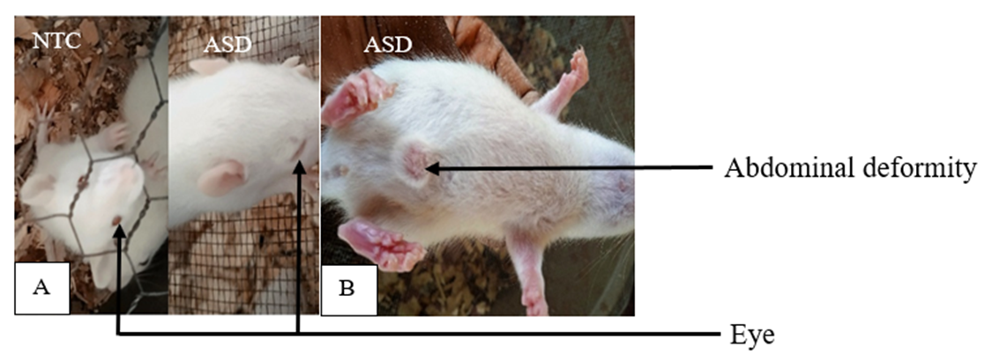

**Figure 1:** Some malformations (A) delayed eye-opening (B) abdominal deformity.

**NTC:** neurotypical animals treated with distilled water (10 mL/kg) **ASD:** ASD animals treated with distilled water (10 mL/kg).

**8.2. Quantitative phytochemical assays**

To assess the phytochemical composition of *P.* *africanum* aqueous extract, the concentrations of secondary metabolites that can specify the plant profile were determined. The water extract of *P.* *africanum* was analyzed, and bioactive compounds were revealed (Table 1). The results expressed showed that *P.* *africanum* has appreciable concentrations of phenolic (205.33 ± 1.11 mg GAE), flavonoid (2.31 ± 0.03 mg RE), phenolic acid (40.03 ± 0.74 mg CAE), flavanol (1.93 ± 0.07 mg CE), tannin (23.84 ± 2.23 mg CE), and saponin (675.81 ± 34.88 mg QE).

**Table****1:**Quantitative phytochemical screening of aqueous extract of *Piptadeniastrum africanum*

|  |  |
| --- | --- |
| Secondary metabolites | Aqueous extract of *P.* *africanum* |
| Phenolic content (mg GAE/g Extract) | 205.33 ± 1.11 |
| Flavonoid content (mg RE/g Extract) | 2.31 ± 0.03 |
| Phenolic acid content (mg CAE/g Extract) | 40.03 ± 0.74 |
| Flavanol content (mg CE/g Extract) | 1.93 ± 0.07 |
| Tannin content (mg CE/g Extract) | 23.84 ± 2.23 |
| Saponin content (mg QE/g Extract) | 675.81 ± 34.88 |

Values expressed are means ± SD. n=3. GAE: Gallic acid equivalent; RE: Rutin equivalent; CAE: Caffeic acid equivalent; CE: Catechin equivalent; QE: Quillaja equivalent.

**8.3. *In vitro* investigation of the antioxidant potential**

Table 2 presents inhibitory concentrations 50 of the aqueous extract of the *P. africanum* bark for the DPPH, ABTS, and FRAP radicals. It is apparent from this table that the inhibitory concentration 50 (IC50) of vitamin C was 1.20 µg/mL, and that of the extract was 58.945 µg/mL for the radical DPPH. The IC50 of vitamin C was 4.15 µg/mL and 46.91 µg/mL *P. africanum* extract regarding the radical ABTS. For the FRAP radical, the concentration IC50 was 165.00 µg/mL, and that of vitamin C was 8.18 µg/mL.

**Table 2:** *In vitro* scavenging potential of *Piptadeniastrum africanum*

|  |  |  |  |
| --- | --- | --- | --- |
|  | IC50FRAP (µg/mL) | IC50 DPPH (µg/mL) | IC50 de ABTS (µg/mL) |
| Ascorbic acid | 8.18 | 1.20 | 4.15 |
| *P. africanum* extract | 165.00 | 58.94 | 46.91 |

Values expressed are means ± SD. n=3. **IC50**: Inhibitory concentration 50 ; **FRAP**: Ferric Reducing Antioxidant Power; **DPPH**: 2,2-Diphenyl-1-picrylhydrazyl; **ABTS**: 2,2′-azino-bis-(3-ethylbenzothiazoline-6-sulfonic) acid)

**8.4. *P. africanum* effects on some behavioral disorders**

**8.4.1. Effects on exploratory activity and social interaction**

The data presented in Figure 2 is based on three-chamber social paradigm tests. The effects of *P. africanum* on the time to leave the central compartment of the sociability cage are illustrated in Figure 2A. Fetuses exposed to sodium valproate (VPA) on gestation days 11-13 needed more time to leave the central compartment of the sociability cage. This increased by 28.5% (p<0.001) after 28 days (wave 1) and 59.09% (p<0.001) after 37 days (wave 2). *P. africanum* extract increased the exploration activity by reducing the time taken to leave the central compartment of the sociability cage in test subjects exposed to sodium valproate (VPA). The extract also increased interaction time with the former congener and corrected the decreased preference for social novelty. However, the administration of *P. africanum* extract at 190 mg/kg increased this interaction 18-fold (p<0.001). Bumetanide also increased interaction by 89.64% (p<0.001). The negative control group showed a decreased preference for social novelty in both waves.

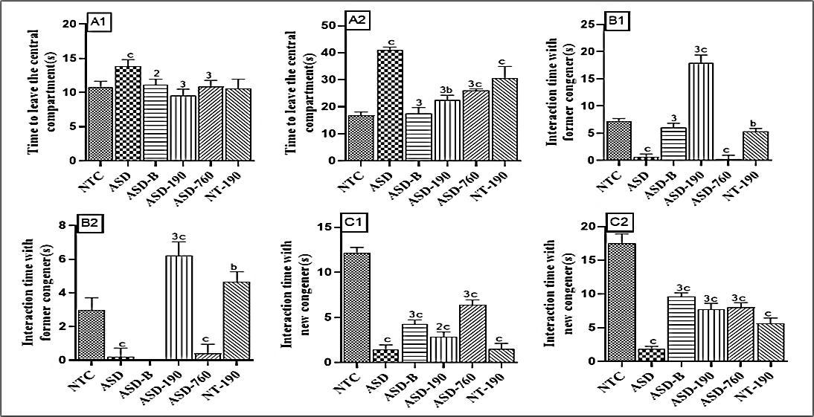

**Figure 2:** Effects of *Piptadeniastrum africanum* on exploratory activity (A1, A2) and social interaction (B1, B2, and C1, C2)

Each bar represents the mean ± MSE; n=5. Each bar represents the mean ± MSE; n=5. ap<0.05; bp<0.01; cp<0.001: significant differences versus NTC. 1p<0.05; 2p<0.01; 3p<0.001: significant differences versus ASD. **NTC:** neurotypical animals treated with distilled water (10 mL/kg) **ASD:** ASD animal treated with distilled water (10 mL/kg); **ASD-B:** ASD animal treated at Bumetanide (4 mg/kg); **ASD-190, ASD-760:** ASD animals treated with the aqueous extract *P. africanum* at doses of 190 and 760 mg/kg; **NT-190:** neurotypical animal treated with the aqueous extract from *P. africanum* at dose of 190 mg/kg. 1 and 2 designate waves 1 and 2, respectively

**8.4.2. Effects on** **stereotyped behavior**

Figures 3A and 3B show that grooming and burials increased significantly 28 days (wave 1) and 37 days (wave 2) after weaning. The negative control showed a 70-76.4% increase in grooming and a 62.23% to 4-fold increase in burrowing compared to the NTC. The extract of *Piptadeniastrum africanum* at 190 and 760 mg/kg and bumetanide reduced grooming by 72.4-73.6% in wave 1 and 32.16-81.11% in wave 2 compared to the negative control. The 190 and 760 mg/kg doses of plant extract in wave 1 resulted in a 40-50% decrease in burials compared to the ASD control. In wave 2, the 190 and 760 mg/kg doses and bumetanide showed a 30-75% decline compared to the ASD control. The pharmacological control showed an increase in the number of groomings in both waves compared to the NTC control.

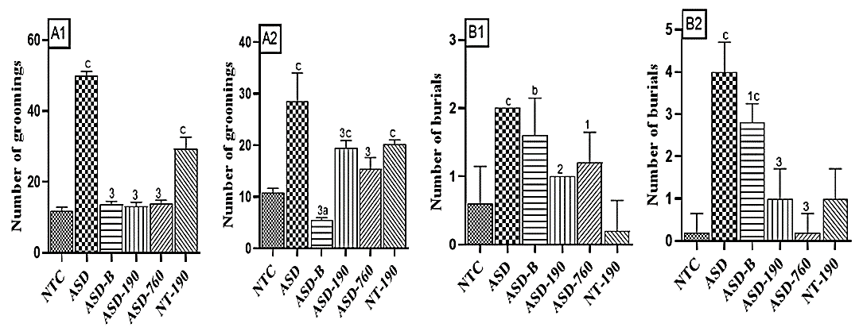

**Figure 3**: Effects of *Piptadeniastrum africanum* aqueous extract on groomings (A1, A2) and burials (B1, B2)

Each bar represents the mean ± MSE; n=5. bp<0.01; cp<0.001: significant differences versus NTC. 1p<0.05; 2p<0.01: significant differences versus ASD. **NTC:** neurotypical animals treated with distilled water (10 mL/kg) **ASD:** ASD animal treated with distilled water (10 mL/kg); **ASD-B:** ASD animal treated at bumetanide (4 mg/kg); **ASD-190, ASD-760:** ASD animals treated with the aqueous extract *P. africanum* at doses of 190 and 760 mg/kg; **NT-190:** neurotypical animal treated with the aqueous extract from *P. africanum* at the dose of 190 mg/kg. 1 and 2 designate waves 1 and 2, respectively.

**8.4.3. Effects on exploratory activity and anxiety in** **the open arena test**

The open arena test (OA) is a commonly used ethological approach to evaluate anxiety-like behavior in murine models—exposure to sodium valproate *in utero*. Data of OA are presented in Table 3. For wave 1, The time spent in the center of the arena by rats in the ASD group (2.20±0.20 s) was significantly reduced compared to NTS animals (1.19±0.02 s). However, *P. africanum* extract with a 190 mg/kg dosage increased the time spent by 40.51% for wave 1 and 68.75% for wave 2. The negative control group showed a significant increase in turnarounds compared to NTC. In the present study, the aqueous extract of *P. africanum* at 190 and 760 mg/kg reduced the number of turnarounds. Bumetanide also reduced the number of turnarounds by 30% (p<0.001) in wave 1 and by 40% (p<0.05) in wave 2 compared to ASD animals.

The study found that after weaning, ASD rats treated with *P. africanum* at 190 mg/kg showed a 31.62% increase, while those given the 760 mg/kg extract dose showed a 47% increase in the number of lines crossed. Bumetanide also showed a 53.75% increase compared to the negative control. The administration of these doses increased exploration by 34.66%, 53.78%, and 38.64%, respectively, compared to NTC rats. These results were consistent in the second wave, with the 190 mg/kg dose of extract and Bumetanide showing increases of 59.22% (p<0.001) and 49.51% (p<0.01), respectively, compared to the NTC animals.

Data from the OA are consistent with VPA's on stereotyped behavior. Indeed, the number of groomings in the open arena increased in the negative control compared with the normal by 56.93% (p<0.001) in wave 1 and 52.85% (p<0.001) in wave 2. Treatment with extract at doses of 190 and 760 mg/kg and with bumetanide decreased the number of groomings compared with the negative respectively by 24.54% (p<0.01), 19.70% (p<0.05) and 32.11% (p<0.001) in wave 1 and by 72.88% (p<0.001), 86.44% (p<0.001) and 57.62% (p<0.01) compared with the NTC rats. Compared to the ASD group in the second wave, the number of groomings was reduced by 36.42% (p<0.001) for the 190 mg/kg dose of extract, by 22.85% (p<0.05) for bumetanide and by 69.69% (p<0.001) for the 760 mg/kg dose of extract.

**Table 3:** Effects of *Piptadeniastrum africanum* aqueous extract on exploratory activity and anxiety

|  |  |  |  |  |
| --- | --- | --- | --- | --- |
|  | Time spent at the center (s) | Number of regressions | Number of lines crossed | Number of groomings |
| NTC | 2.20±0.20  (1.07±0.07) | 4.00±0.31  (3.60±0.24) | 36.60±1.12  (50.20±1.77) | 11.80±0.48  (13.20±0.20) |
| ASD | 1.19±0.022  (1.00±0.00) | 8.00±0.31c  (6.40±0.24)c | 23.40±0.60c  (20.60±0.60)c | 27.40±2.20c  (28.00±1.89)c |
| ASD-B | 1.60±0.24  (0.95±0.16) | 5.60±0.243a  (5.80±0.20)c | 50.60±0.603c  (30.80±2.05)2c | 18.60±0.923b  (21.60±1.03)1b |
| ASD-190 | 2.00±0.01  (3.20±0.12)3c | 4.60±0.243  (5.20±0.20)1c | 30.80±1.313c  (32.80±1.88)3c | 20.40±0.502c  (22.40±1.74)3 |
| ASD-760 | 2.65±0.203  (0.88±0.12) | 3.20±0.20  (1.80±0.20)3c | 34.40±0.503  (23.20±1.82)c | 22.00±1.041c  (22.40±1.47)c |
| NT-190 | 1.54±0.18  (2.28±0.17)c | 3.00±0.44  (3.60±0.24) | 30.00±0.31c  (35.20±1.74)c | 12.00±0.44  (22.40±1.74)c |

Each value represents the mean ± MSE; n=5. ap<0.05; bp<0.01; cp<0.001: significant differences versus NTC. 1p<0.05; 2p<0.01; 3p<0.001: significant differences versus ASD. **NTC:** neurotypical animals treated with distilled water (10 mL/kg) **ASD:** ASD animal treated with distilled water (10 mL/kg); **ASD-B:** ASD animal treated at bumetanide (4 mg/kg); **ASD-190, ASD-760:** ASD animals treated with the aqueous extract *P. africanum* at doses of 190 and 760 mg/kg; **NT-190:** neurotypical animal treated with the aqueous extract from *P. africanum* at dose of 190 mg/kg. Wave 1 (starting 28 days after weaning) is represented by data outside brackets. Wave 2 (starting 37 days after weaning) is represented by data in brackets.

**8.4.4. Effects on exploratory activity and anxiety in the** **elevated plus maze**

Data from the elevated plus maze test (EPM), a standard screening for putative anxiolytic compounds, are resumed in Table 4. In the study, the time spent in open arms decreased in the ASD group compared to NTC animals by 92.41% and 96.24% in waves 1 and 2, respectively. However, extract doses of 190 and 760 mg/kg significantly increased the time spent in open arms. Bumetanide also increased the time spent in open arms in both waves. In the NTC group, the time spent in open arms increased significantly compared to the neurotypical control during wave 1. Furthermore, the ASD group had 80% fewer open-arm entries than the normal control group. However, the group that received an extract of 190 mg/kg had a 2.5-fold increase in open arm entries in wave 1 and an 83% increase in wave 2 compared to the negative control group. The 760 mg/kg dose of extract showed even more promising results. It increased the number of open arm entries by 3-fold in wave 1 and by 80% in wave 2 compared to the negative control group. Bumetanide increased the number of entries into the open arms by 85.71% in wave 1 compared to the negative control group. The administration of *P. africanum* at 190 mg/kg showed a significant decrease in time spent in the closed arms. In wave 1, there was a 23.77% decrease compared to the ASD group and a 25.05% decrease for the 760 mg/kg extract dose. In wave 2, the time spent in the closed arms was reduced by 8.84% for the 190 mg/kg dose of extract and by 7.63% for bumetanide compared to the negative control group. The group exposed to sodium valproate in utero had significantly more entries into the closed arms than the NTC. However, the treatment per os with *P. africanum* at 190 mg/kg reduced this number by 58.33% for wave 2 compared to ASD rats.

During the experiment, it was found that the number of movements in the elevated cross significantly increased in the negative control compared to NTC. However, treatment with the extract at doses of 190 and 760 mg/kg and bumetanide reduced the number of movements. In addition, the number of head falls increased in the pharmacological control, but P. Africanum and bumetanide restored the number of grooming activities to average values. The number of sit-ups and groomings increased in the pharmacological control compared to NTC. The study found that treatment with the *P. africanum* extract at all doses reduced the number of movements in the elevated cross by 58.33% and 83.33%, respectively, compared to the negative control. Bumetanide also reduced the number of movements in the second wave. The number of head falls increased in the pharmacological control group compared to the neurotypical rats in the first wave but was restored to standard value by *P. africanum* and bumetanide. The number of sit-ups increased in the pharmacological control group compared to NTC in the second wave. Additionally, the number of groomings in the pharmacological control group increased compared to NTC in both waves.

**Table 4**: Effects of *Piptadeniastrum africanum* aqueous extract on exploratory activity and anxiety in the elevated cross-maze

|  |  |  |  |  |  |  |  |
| --- | --- | --- | --- | --- | --- | --- | --- |
|  | Time spent in the BO(s) | Number of entries in the BO | Time spent in the BF(s) | Number of entries in the BF | Number of regression | Number of headfalls | Number of groomings |
| NTC | 10.55±0.25  (5.33±0.18) | 1.00±0.00  (1.00±0.00) | 267.60±5.66  (272.00±2.93) | 1.80±0.20  (1.40±0.24) | 2.40±0.24  (2.40±0.24) | 1.00±0.00  (0.80±0.20) | 17.40±0.40  (25.00±1.97) |
| ASD | 0.80±0.20c  (0.20±0.20)c | 0.20±0.20a  (0.20±0.20)a | 290.70±2.18  (292.30±2.22)a | 3.20±0.20b  (2.40±0.24)a | 4.80±0.37c  (6.40±0.24)c | 0.40±0.24  (0.00±0.00) | 57.00±0.83c  (53.60±2.01)c |
| ASD-B | 7.00±0.313c  (9.16±0.70)3c | 1.40±0.242  (0.80±0.20) | 277.00±4.75  (270.00±2.58)2 | 2.00±0.311  (2.40±0.24)a | 4.80±0.37c  (4.40±0.24)3c | 0.60±0.24  (0.80±0.37) | 16.80±0.373  (28.40±1.20)3 |
| ASD-190 | 15.12±0.363c  (11.55±0.42)3c | 2.00±0.003b  (1.20±0.20)2 | 221.60±10.173b  (266.50±7.78)2 | 2.60±0.24  (1.00±0.00)2 | 2.00±0.313  (5.00±0.31)1c | 1.40±0.241  (1.60±0.40)2 | 38.40±2.063c  (36.40±1.16) 3c |
| ASD-760 | 20.57±0.263c  (11.80±0.37)3c | 2.20±0.203b  (1.00±0.00)1 | 217.90±9.343b  (275.80±3.38) | 1.40±0.243  (1.60±0.24) | 0.80±0.373a  (1.00±0.31)3a | 1.40±0.241  (2.20±0.20)3a | 45.40±2.313c  (40.80±2.17)3c |
| NT-190 | 18.87±0.42c  (5.45±0.24) | 1.40±0.24  (0.80±0.20) | 239.30±12.15  (280.70±1.00) | 2.00±0.31  (1.80±0.20) | 2.40±0.24  (3.60±0.24)a | 2.40±0.24b  (0.40±0.24) | 48.40±1.93c  (49.60±1.16)c |

Each value represents the mean ± MSE; n=5. ap<0.05; bp<0.01; cp<0.001: significant differences vs NTC. 1p<0.05; 2p<0.01; 3p<0.001: significant differences vs ASD. **NTC:** neurotypical animals treated with distilled water (10 mL/kg) **ASD:** ASD animal treated with distilled water (10 mL/kg); **ASD-B:** ASD animal treated at bumetanide (4 mg/kg); **ASD-190, ASD-760:** ASD animals treated with the aqueous extract *P. africanum* at doses of 190 and 760 mg/kg; **NT-190:** neurotypical animal treated with the aqueous extract from *P. africanum* at the dose of 190 mg/kg. 1 and 2 designate waves 1 and 2, respectively.

**8.4.5. Effects on pain sensitivity during the** **hot plate test**

Treatment with sodium valproate (VPA) during pregnancy has been shown to cause a reduction in the time it takes for the offspring to respond to pain stimuli 28 and 37 days after weaning. This was observed through a decrease of 57.5% (wave 1) and 44% (wave 2) in the negative control compared to NTC animals on the hot plate. However, doses of 190 and 760 mg/kg of the extract increased the response time by 35% and 47.05%, respectively, for wave 1. For wave 2, the 190 mg/kg extract and Bumetanide increased the latency time by 64.28% and 42.28%, respectively, compared to the negative control. The pharmacological control decreased by 40% (wave 1) and 20% (wave 2) compared to neurotypical rats. *P. africanum* at 190 mg/kg and 760 mg/kg, as well as Bumetanide, increased response time compared to the NTC group. This increase was 45.50% and 37.50% for the 190 mg/kg and 760 mg/kg doses of extract, respectively, and 52.50% for bumetanide in wave 1.

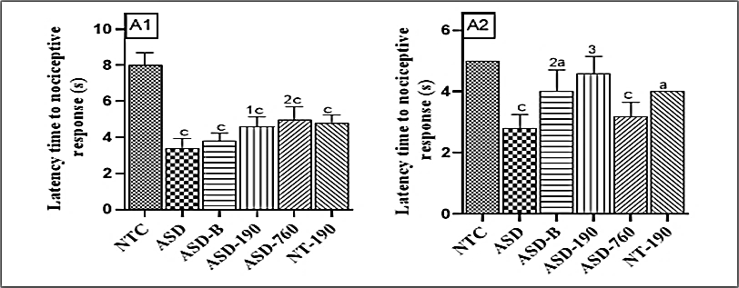

**Figure 3:** Effects of *Piptadeniastrum africanum* aqueous extract on pain sensitivity during the hot plate test (A1, A2)

Each bar represents the mean ± MSE; n=5. ap<0.05; cp<0.001: significant differences versus NTC. 1p<0.05; 2p<0.01: significant differences versus ASD. **NTC:** neurotypical animals treated with distilled water (10 mL/kg) **ASD:** ASD animal treated with distilled water (10 mL/kg); **ASD-B:** ASD animal treated at Bumetanide (4 mg/kg); **ASD-190, ASD-760:** ASD animals treated with the aqueous extract *P. africanum* at doses of 190 and 760 mg/kg; **NT-190:** neurotypical animal treated with the aqueous extract from *P. africanum* at the dose of 190 mg/kg. 1 and 2 designate waves 1 and 2, respectively.

**8.5. Effects on some biochemical parameters**

**8.5.1. Effects on GABA levels**

During gestation days 11, 12, and 13, female animals treated with sodium valproate showed increased GABA concentration in various brain areas compared to ASD control. This increase was nearly 2.5-fold in the cerebellum, prefrontal cortex, and hippocampus and 5-fold in the amygdala. The administration of *P. africanum* at 190 and 760 mg/kg decreased GABA concentration in the cerebellum and prefrontal cortex. Bumetanide also caused a reduction in GABA concentration in the cerebellum. However, the pharmacological control showed increased GABA concentration in the prefrontal cortex, hippocampus, and amygdala compared to the neurotypical animals. The extract corrected the increase in GABA concentration in the hippocampus and amygdala. The concentration of GABA decreased in all areas of the brain in animals treated with 190 mg/kg of the extract compared to the negative control. Similarly, the concentration of GABA decreased in the prefrontal cortex, hippocampus, and amygdala in animals treated with 760 mg/kg of the extract. Bumetanide also caused a decrease in GABA concentration in all areas of the brain compared to the neurotypical rats.

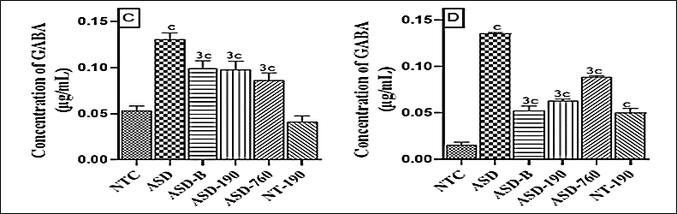

Effects of *Piptadeniastrum africanum* aqueous extract on GABA concentration in hippocampus (C), and amygdala (D).

Each bar represents the mean ± MSE; n=5. cp<0.001: significant differences versus NTC. 3p<0.001: significant differences versus ASD. **NTC:** neurotypical animals treated with distilled water (10 mL/kg) **ASD:** ASD animal treated with distilled water (10 mL/kg); **ASD-B:** ASD animal treated at Bumetanide (4 mg/kg); **ASD-190, ASD-760:** ASD animals treated with the aqueous extract *P. africanum* at doses of 190 and 760 mg/kg; **NT-190:** neurotypical animal treated with the aqueous extract from *P. africanum* at dose of 190 mg/kg. 1 and 2 designate waves 1 and 2, respectively.

**8.5.2. Effects on GABA-T activity**

GABA-T activity in the hippocampus (Figure 5C) after administration of sodium valproate to pregnant females decreased by 69,02% (p<0.001) in the ASD control compared with the neurotypical animals and by 41.41% (p<0.001) in the pharmacological control compared with the NTC group after birth. Treatment with both *P. africanum* extract and bumetanide corrected this decrease, with rates of increase of 60.66% (p<0.001) for the 190 mg/kg dose, 53.84% (p<0.001) for the 760 mg/kg dose of extract and 42.85% (p<0.01) for Bumetanide in ASD animal compared to the vehicle control. In the amygdala (Figure 5D), there was a 2.5-fold (p<0.001) increase in GABA-T activity due to the 190 mg/kg dose compared with the negative control and a 67.92% (p<0.001) increase compared with the NTC rats. Compared with the neurotypical rats, GABA-T activity in the hippocampus was increased by 19.52% (p<0.01), 33.67% (p<0.001) for 190 and 760 mg/kg extract, and 45.79% (p<0.001) for bumetanide.

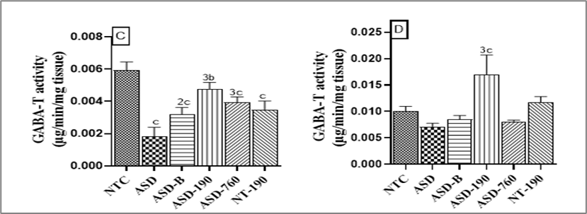

**Figure 5:** Effects of *Piptadeniastrum africanum* aqueous extract on GABA-T activity in the hippocampus (C) and amygdala (D).

Each bar represents the mean ± MSE; n=5. bp<0.01; cp<0.001: significant differences versus NTC. 2p<0.01; 3p<0.001: significant differences versus ASD. **NTC:** neurotypical animals treated with distilled water (10 mL/kg) **ASD:** ASD animal treated with distilled water (10 mL/kg); **ASD-B:** ASD animal treated at Bumetanide (4 mg/kg); **ASD-190, ASD-760:** ASD animals treated with the aqueous extract *P. africanum* at doses of 190 and 760 mg/kg; **NT-190:** neurotypical animal treated with the aqueous extract from *P. africanum* at dose of 190 mg/kg. 1 and 2 designate waves 1 and 2, respectively.

**8.5.3. Effects on L-GAD activity**

An increase in L-GAD activity was recorded in the ASD animals in the cerebellum (Figure 6A), prefrontal cortex (Figure 6B), hippocampus (Figure 6C), and amygdala (Figure 6D). Compared with neurotypical rats, this elevation was 8-fold (p<0.001), 63.41% (p<0.001), 3-fold (p<0.001) and 2.5-fold (p<0.001) respectively. The daily treatment with *P. africanum* extract at 190 mg/kg dose of the extract, compared with the NTC, favored the reduction of L-GAD activity, with reduction rates of 92.85% (p<0.001) in the cerebellum, 32.83% (p<0.001) in the prefrontal cortex, 38.70% (p<0.001) in the hippocampus and 76.25% (p<0.001) in the amygdala. The low-down effects of the plant extract on L-GAD activity were more noticeable at 760 mg/kg. It was by 63.63% (p<0.05) in the cerebellum, 41.46% (p<0.001) in the prefrontal cortex, and 52.50% (p<0.001) in the hippocampus, compared with ASD control. Bumetanide (4 mg/kg) decreased L-GAD activity in ASD rats by 86.3% (p<0.001) in the cerebellum and 62% (p<0.001) in the hippocampus.

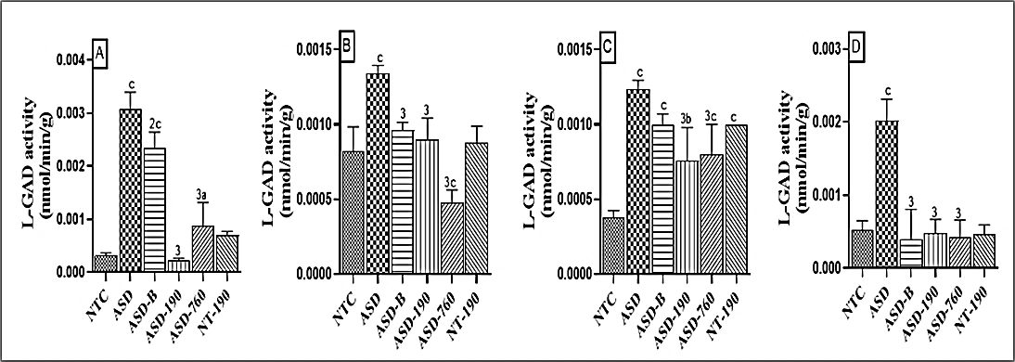

**Figure 6:** Effects of *Piptadeniastrum africanum* aqueous extract on L-GAD activity in the cerebellum (A), prefrontal cortex (B), hippocampus (C), and amygdala (D).

Each bar represents the mean ± MSE; n=5. ap<0.05; bp<0.01; cp<0.001: significant differences versus NTC. 2p<0.01; 3p<0.001: significant differences versus ASD. **NTC:** neurotypical animals treated with distilled water (10 mL/kg) **ASD:** ASD animal treated with distilled water (10 mL/kg); **ASD-B:** ASD animal treated at Bumetanide (4 mg/kg); **ASD-190, ASD-760:** ASD animals treated with the aqueous extract *P. africanum* at doses of 190 and 760 mg/kg; **NT-190:** neurotypical animal treated with the aqueous extract from *P. africanum* at dose of 190 mg/kg. 1 and 2 designate waves 1 and 2, respectively.

**8.5.4. Effects on serotonin levels**

Serotonin (5-HT) concentration was significantly increased in ASD animals in the various brain regions considered. Compared with the neurotypical rats, there was an increase of 60.22% (p<0.001), 90.07% (p<0.001), 60.19% (p<0.001), and 61.84% (p<0.001), respectively, in the cerebellum (Figure 7A), prefrontal cortex (Figure 7B), hippocampus (Figure 7C) and amygdala (Figure 7D). Treatment with different doses of the extract and bumetanide resulted in a significant drop in serotonin levels. At 190mg/kg, compared with the ASD control, P. africanum reduced 5-HT levels by 30.04% (p<0.001), 17.78% (p<0.05), 51.18% (p<0.001), and 49.21% (p<0.001). Bumetanide induced a likewise decrease of 5-HT concentrations by 45.75% (p<0.001), 26% (p<0.001) in the cerebellum and prefrontal cortex, respectively, 60.64% (p<0.001) in the hippocampus and 54.12% (p<0.001) in the amygdala compared with the ASD control.

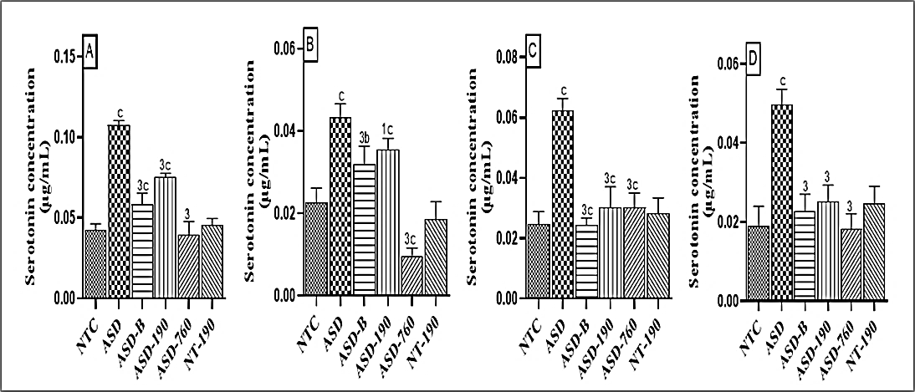

**Figure 7:** Effects of *Piptadeniastrum africanum* aqueous extract on serotonin concentration in the cerebellum(A), prefrontal cortex(B), hippocampus(C), and amygdala (D).

Each bar represents the mean ± MSE; n=5. bp<0.01; cp<0.001: significant differences from normal control. 1p<0.05; 3p<0.001: significant differences from negative control. **NTC:** neurotypical animals treated with distilled water (10 mL/kg) **ASD:** ASD animal treated with distilled water (10 mL/kg); **ASD-B:** ASD animal treated at Bumetanide (4 mg/kg); **ASD-190, ASD-760:** ASD animals treated with the aqueous extract *P. africanum* at doses of 190 and 760 mg/kg; **NT-190:** neurotypical animal treated with the aqueous extract from *P. africanum* at dose of 190 mg/kg. 1 and 2 designate waves 1 and 2, respectively.

**8.6. Effects on some markers of oxidative stress**

**8.6.1. Effects on reduced glutathione concentration**

Impairment of glutathione function in the brain is linked to the loss of neurons during aging or as a result of neurological diseases. As shown in Figure 8, sodium valproate administration to females decreased the GSH concentration in offspring. In the ASD rats, the extract at doses of 190 and 760 mg/kg increased GSH concentration in the cerebellum by 4-fold and 5-fold, respectively. In animals treated with *P. africanum* extract, GSH concentration increased by 40.11% (p<0.001) in the cerebellum, 13.41% (p<0.01) in the hippocampus, and 70.36% (p<0.001) in the amygdala, compared to the neurotypical animals. Bumetanide also increased GSH concentration in various regions of the brain.

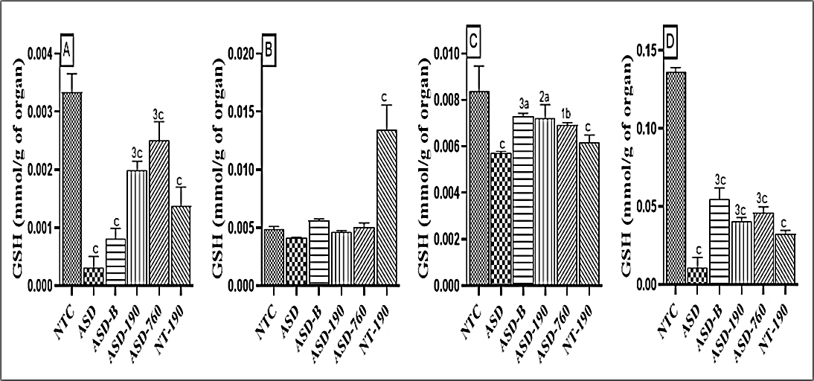

**Figure 8:** Effects of *Piptadeniastrum africanum* aqueous extract on reduced glutathione concentration in the cerebellum (A), prefrontal cortex (B), hippocampus (C), and amygdala (D).

Each bar represents the mean ± MSE; n=5. ap<0.05; bp<0.01; cp<0.001: significant differences versus NTC. 1p<0.05; 2p<0.01; 3p<0.001: significant differences versus ASD. **NTC:** neurotypical animals treated with distilled water (10 mL/kg) **ASD:** ASD animal treated with distilled water (10 mL/kg); **ASD-B:** ASD animal treated at Bumetanide (4 mg/kg); **ASD-190, ASD-760:** ASD animals treated with the aqueous extract *P. africanum* at doses of 190 and 760 mg/kg; **NT-190:** neurotypical animal treated with the aqueous extract from *P. africanum* at dose of 190 mg/kg. 1 and 2 designate waves 1 and 2, respectively.

**8.6.2. Effects on malondialdehyde levels**

Malondialdehyde (MDA) is a marker of oxidative stress and one of the cells' final products of polyunsaturated fatty acids peroxidation. MDA concentration increased in the negative control group's cerebellum, prefrontal cortex, hippocampus, and amygdala. Compared to the neurotypical control group, MDA levels increased by 73.45% (p<0.001) in the cerebellum and hippocampus and 2.5-fold in the prefrontal cortex and amygdala in the offspring of female VPA-treated. The NT-190 control group also showed an increase in MDA concentration. The administration of the extract at a dose of 190 mg/kg and 760 mg/kg decreased the MDA concentration in the cerebellum, prefrontal cortex, hippocampus, and amygdala, compared to the negative control group (p<0.001). The Bumetanide-treated group observed decreased MDA concentration in the prefrontal cortex, hippocampus, and amygdala compared to the negative control group (p<0.001). However, MDA concentration after Bumetanide administration increased in the cerebellum and amygdala compared to the neurotypical control group. The extract's 190 mg/kg dose increased MDA concentration in the prefrontal cortex, hippocampus, and amygdala compared to the NTC rats (p<0.001).

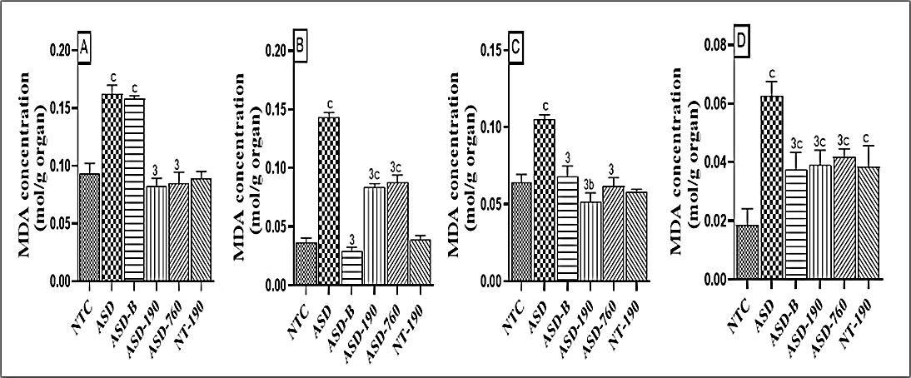

**Figure 9:** Effects of *Piptadeniastrum africanum* aqueous extract on malondialdehyde concentration in the cerebellum (A), prefrontal cortex (B), hippocampus (C), and amygdala (D).

Each bar represents the mean ± MSE; n=5. bp<0.01; cp<0.001: significant differences versus NTC. 3p<0.001: significant difference versus ASD. **NTC:** neurotypical animals treated with distilled water (10 mL/kg) **ASD:** ASD animal treated with distilled water (10 mL/kg); **ASD-B:** ASD animal treated at Bumetanide (4 mg/kg); **ASD-190, ASD-760:** ASD animals treated with the aqueous extract *P. africanum* at doses of 190 and 760 mg/kg; **NT-190:** neurotypical animal treated with the aqueous extract from *P. africanum* at a dose of 190 mg/kg. 1 and 2 designate waves 1 and 2, respectively.

**8.6.3. Effects on superoxide dismutase activity**

SOD constitutes a critical antioxidant defense against oxidative stress in the body and catalyzes the dismutation of superoxide anion free radical (O2-) into molecular oxygen and hydrogen peroxide (H2O2)activity significantly decreased in the negative control group compared to the neurotypical animals. As shown in Figure 10, in the administration of sodium valproate in the cerebellum, there was a decrease of 65.53%; in the prefrontal cortex, there was a decrease of 46.10%; in the hippocampus, there was a decrease of 88.91%; and in the amygdala, there was a decrease of 35.77%. The 190 mg/kg extract and Bumetanide increased SOD activity in the cerebellum, prefrontal cortex, hippocampus, and amygdala compared to the negative control. SOD activity doubled in animals treated with 190 mg/kg of plant extract compared to the NTC group. Compared with the NTC group, SOD activity in the batch treated with 760 mg/kg of the extract increased in the cerebellum by 67.80% (p<0.0001), in the prefrontal cortex by 67.89% (p<0.001) and in the hippocampus by 58.72% (p<0.001). In the same direction, Bumetanide and the 190 mg/kg dose promoted an increase of 51.14% (p<0.001) in the prefrontal cortex, 56.36% (p<0.001), 45.75% (p<0.001) in the hippocampus compared with neurotypical rats.

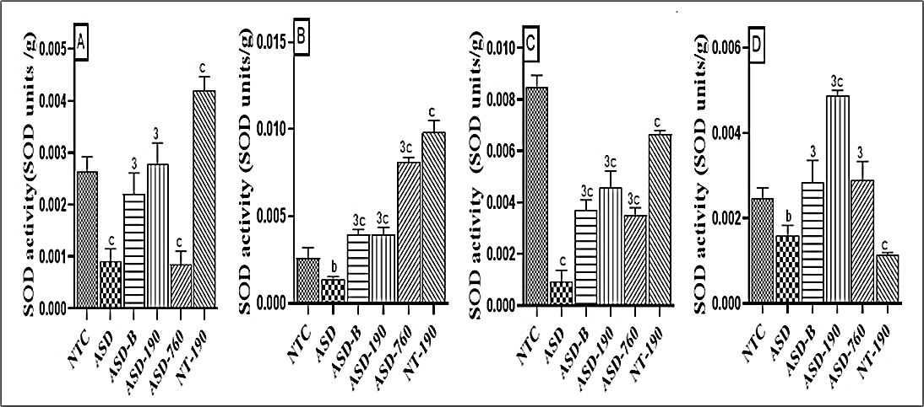

**Figure 10:** Effects of *Piptadeniastrum africanum* aqueous extract on superoxide dismutase activity in cerebellum (A), prefrontal cortex (B), hippocampus (C) and amygdala (D)

Each bar represents the mean ± MSE; n=5. bp<0.01; cp<0.001: significant differences versus NTC. 3p<0.001: significant differences versus ASD. **NTC:** neurotypical animals treated with distilled water (10 mL/kg) **ASD:** ASD animal treated with distilled water (10 mL/kg); **ASD-B:** ASD animal treated at Bumetanide (4 mg/kg); **ASD-190, ASD-760:** ASD animals treated with the aqueous extract *P. africanum* at doses of 190 and 760 mg/kg; **NT-190:** neurotypical animal treated with the aqueous extract from *P. africanum* at a dose of 190 mg/kg. 1 and 2 designate waves 1 and 2, respectively.

**8.7. Effects on the microarchitecture of the cerebellum,** **hippocampus, and amygdala**

Histological analysis confirmed the deleterious effects of administering sodium valproate to pregnant females on the neurons, oligodendrocytes, and neuron organization in the brains of their offspring. According to Figure 11, the H&E staining revealed that ASD rats present an increase of hyperchromatic and vacuolated neurons in the pyramidal cell layer in both CA1 and CA3 of the hippocampus. Furthermore, administering VPA to pregnant females also resulted in oligodendrocyte necrosis associated with cerebral edema in the amygdala, decreased neuronal density in the Purkinje cell layer, and neuronal degeneration in the dentate gyrus. The dentate gyrus is responsible for emotion and memory and is known to be involved in autism spectrum disorders. Compared with neurotypical rats, the aqueous extract of *P. africanum* and bumetanide attenuated these alterations.

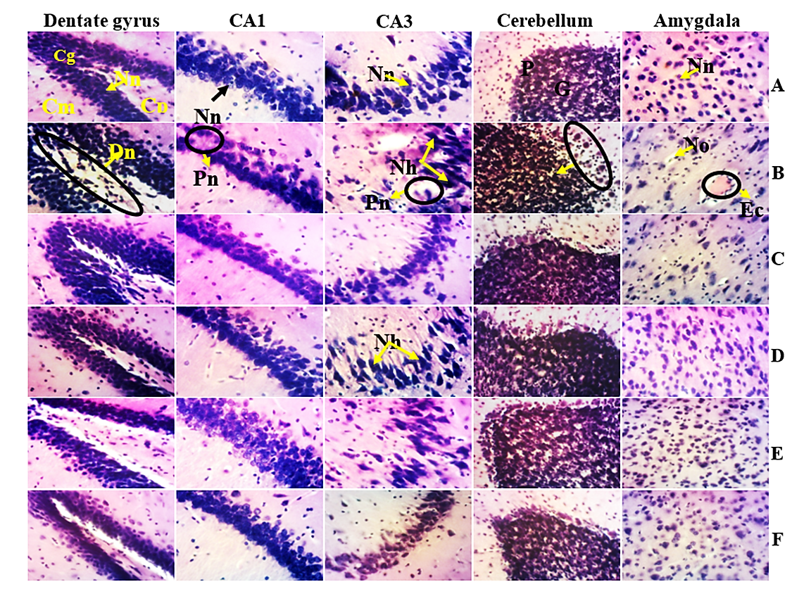

**Figure 11:** Microphotographs of the microarchitecture of the cerebellum, amygdala, and hippocampus (200x, H&E)

**A** = neurotypical animals receiving distilled water (10 mL/kg); **B** = ASD animals receiving distilled water (10 mL/kg); **C** = ASD animals receiving reference drug. **D, E** = ASD animals receiving the aqueous extract of *P. africanum* at 190 and 760 mg/kg; **F** = neurotypical animals receiving the aqueous extract of *P. africanum* at 190 mg/kg. CA1 and CA3: Ammon horn regions1 and 2; **Cg** = Granular cell layer; **Cm** = Molecular layer; **Cp** = Polymorphic cell layer; **Dn** = Neuronal degeneration; **Ec** = Cerebral edema; **G** = Granular cell layer; **Nh** = Hyperchromatic nucleus; **Nn** = Normal neuron; **No** = Oligodendrocyte necrosis; **O** = Oligodendrocyte; **P** = Purkinje cell layer; **Pn** = Neuronal loss.

**8.8. Effects on hippocampal and amygdala’s neuronal density**

Compared with the NTC animals, there was a decrease in neuronal density (p<0.001) in the negative control and an increase (p<0.05) in the positive control in the CA1 region. In the same region, compared with the negative control, an increase in neuronal density (p<0.001) was observed in batches treated with 190 and 760 mg/kg extract in the pharmacological control and in the positive control. In the CA3 region, there was an increase (p<0.001) in animals treated with 190 mg/kg compared with the negative control. In the dentate gyrus, there was a decrease in the number of neurons in the negative control compared to the neurotypical control (p<0.05). The density of neurons in the amygdala compared to the NTC animals increased (p<0.05) in animals treated with 760 mg/kg of the extract and decreased (p<0.001) in the negatives. Compared with the negative control, there was an increase (p<0.001) for the 190 and 760 mg/kg doses of extract, for the positive control and for the pharmacological control.

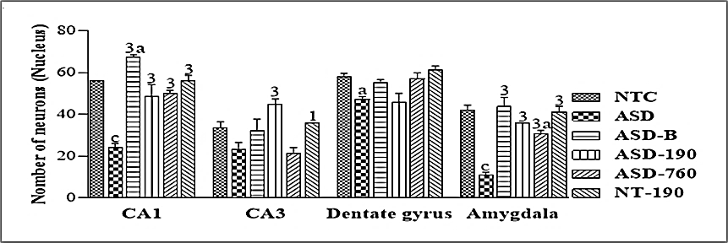

**Figure 12:** Effects of *Piptadeniastrum africanum* aqueous extract on neuron density in the hippocampus and amygdala.

Each bar represents the mean ± MSE; n=5. ap<0.05; cp<0.001: significant differences versus NTC. 1p<0.05; 3p<0.001: significant differences versus ASD. **NTC:** treated with distilled water (10 mL/kg) **ASD:** ASD animal treated with distilled water (10 mL/kg); **ASD-B:** ASD animal treated at Bumetanide (4 mg/kg); **ASD-190, ASD-760:** ASD animals treated with the aqueous extract of *P. africanum* at doses of 190 and 760 mg/kg; **NT-190:** neurotypical animal treated with the aqueous extract from *P. africanum* at dose of 190 mg/kg. 1 and 2 designate waves 1 and 2, respectively.

**9. Discussion**

Autism spectrum disorder (ASD) is a neurodevelopmental condition affecting around one birth out of 150 worldwide. It is characterized by atypical social communication, repetitive behaviors, and sensory-motor issues. Pain reactivity is also common in individuals with ASD (Elsabbagh et al., 2012; Bogdanova et al., 2022). The current study aimed to evaluate the anti-stereotypic, anxiolytic, and analgesic potentials of the aqueous extract of *Piptadeniastrum africanum* bark on a sodium valproate-induced model of autism in young Wistar rats. Oral administration of 800 mg/kg sodium valproate to pregnant females on gestation days 11, 12, and 13 induced autistic-like disorders in the offspring. Histone deacetylase plays an essential role during embryogenesis, inhibiting the effects of loss-of-function mutations in the developing embryo (Tseng et al., 2022). The present study shows that sodium valproate caused malformations in the offspring, the most representative of which were delayed eye opening and abdominal deformity. By hyperacetylating histones in the cells, sodium valproate inhibited histone deacetylase (HDAC), resulting in the expression of anti-apoptotic genes. This would lead to overexpression of genes from various exogenous and endogenous promoters, resulting in morphological defects (Phiel *et al.,* 2001; Burenkova et al., 2015). The results obtained after exposure to sodium valproate in the present study are similar to those of Zhao *et al.,* who demonstrated in 2019 that prenatal administration of sodium valproate during embryogenesis resulted in a polymalformative syndrome in the offspring.

Behavioral analysis shows sodium valproate induced an anxious state and impaired social behavior in the offspring in the 3-chamber sociability cage and the stereotypy test. Anxious behavior was also recorded in the open arena test. Indeed, in their work, Raza *et al.* (2015) showed that anxiety disorders are the most characteristic behavioral disorders in autism. Kim *et al.* (2011) support this idea by demonstrating that behavioral disorders in ASD in rats are merely a result of an ongoing anxious state. In support of this anxiety, the elevated plus maze test showed a decrease in both time taken and number of entries in the open arms, an increase in the same parameters in the closed arms, an increase in the number of groomings and sit-ups, and a decrease in the number of head drops. These observations are similar to those of Chaliha *et al.,* 2020, who systematically demonstrated that gestational exposure to 600 mg/kg VPA in rodents at around 11.5 to 12.5 days gestation has disruptive effects on the 3 essential behavioral traits characteristic of ASD, with a reduction in social behaviors, an increase in repetitive behaviors and a rise in anxious behaviors reflecting cognitive rigidity.

Indeed, histology shows that prenatal administration of sodium valproate in rodents resulted in lesions of the amygdala, cerebellum, and hippocampus, brain regions involved in regulating emotions and social behavior (Kim *et al.,* 2011). In this way, VPA causes deficiencies in controlling emotions and behaviors. The development of anxiety in autism could be explained by an increase in GABA and serotonin in the brain. In the present study, analysis of markers of GABA metabolism showed a significant increase in GABA concentration, L-GAD activity, and a significant decrease in GABA-T activity. The pathogenesis of autism is characterized by an increase in the excitation/inhibition ratio in specific brain structures (Main and Kulesza, 2017). Indeed, during neuronal maturation, intracellular chloride ion concentration is elevated in immature neurons due to the high activity of the Na+-K+-Cl- cotransporter (NKCC1). The GABA that opens the chloride-ion-permeable channels is then excitatory (the flow of chloride ions is outward). In contrast, mature neurons have a low intracellular chloride ion concentration (the gradient is reversed) due to the high activity of the type 2 K-Cl transporter (KCC2). Thus, our results corroborate those of Johannessen (2000) and Lin *et al.* (2013), who showed that sodium valproate administered to pregnant females increased GABA bioavailability in the offspring, either by increasing L-GAD activity or by decreasing GABA-T activity. This would result in cerebral hyperactivity, responsible for the anxiety state. Dufour *et al.* (2010) have also shown that alteration of the serotonergic system in autism is responsible for the anxiety state in patients. This study showed increased cerebral tissue serotonin concentration compared with neurotypical animals. Indeed, depending on its receptors, serotonin or 5-hydroxytryptamine (5-HT) can be inhibitory or excitatory (Azmitia *et al.,* 2011). It has an excitatory role by binding to its 5-HT2 and 5-HT3 receptors and an inhibitory role by binding to its 5-HT1 receptors. In autism, the density and function of 5-HT1 receptors are reduced in favor of 5HT2 and 5HT3 receptors, thus the excitatory function. This increases the excitation/inhibition balance, characterizing an anxious state (Azmitia *et al.,* 2011). These results are similar to those of Azmitia *et al.* (2011), in which it is noted that administration of V PA to females at day 12.5 of gestation results in an increase in serotonin levels in the brains of the offspring. Anxiety in autism is also thought to be due to oxidative stress. Prenatal administration of sodium valproate on gestation days 11, 12, and 13 resulted in oxidative stress in the offspring, with increased MDA concentrations, decreased SOD activity, and reduced glutathione (GSH) concentrations in the cerebellum, hippocampus, amygdala, and prefrontal cortex. These results are similar to those of Chen *et al.* 2021, who showed that sodium valproate increased brain and blood MDA concentrations, SOD activity, and GSH concentration. Sodium valproate is believed to cause hypermethylation of antioxidant enzymes (GSH and SOD) in the brains of autistic children (Narita et al., 2010). This hypermethylation prevents the expression of genes that regulate the synthesis of antioxidant enzymes (Narita et al., 2010). Indeed, GSH plays an essential role in the elimination of mitochondrial ROS. Therefore, a drop in GSH would increase ROS, resulting in oxidative stress responsible for inflammation in the brains of people with ASD (Xukun *et al.,* 2022). This inflammation is thought to be responsible for ASD behavior. In addition, the increased vulnerability to oxidative stress observed in autism is linked to decreased glutathione levels and is specific to the brain region. The cerebellum and temporal cortex of children with autism show more significant differences in glutathione concentrations compared with controls (Castejon and Spaw, 2014). The cerebellum plays a vital role in motor control and cognitive functions, such as attention and language. The temporal cortex involves social perception, joint attention, and expressive language. Increased damage to these regions due to low glutathione redox status could explain certain behavioral traits (Castejon and Spaw, 2014). The oxidative stress thus present in ASD is responsible for cellular damage, which would explain the loss and decrease in neuronal density observed in the present study's cerebellum, amygdala, and hippocampus.

Aqueous extract of *Piptadeniastrum africanum* decreased L-GAD activity in the cerebellum, prefrontal cortex, hippocampus, and amygdala and increased GABA-T activity in the hippocampus and amygdala. This resulted in a decrease in GABA concentration in these brain areas. Bumetanide achieved the same results. Bumetanide is a diuretic that specifically antagonizes NKCC1. It prevents chloride ions from entering the cell, restoring GABA's inhibitory action (Bossu and Roux, 2019). Aqueous extract of *P. africanum* would interact with GABA metabolism probably by the exact mechanism via some of its metabolites, such as tannins and flavonoids known to modulate synaptic transmission by inhibiting enzyme systems (Dlamini *et al.,* 2019). In addition, tannins are polyphenols with diuretic activity and could modulate L-GAD and GABA-T activity (Johannessen., 2000). Thanks to their anxiolytic properties, flavonoids modulate serotonin activity at their receptors, lowering its concentration in the brain (Okponanabofa *et al.,* 2019). The aqueous extract of *P. africanum* reduced oxidative stress in the brain, suggesting the plant extract has antioxidant activity. Qualitative phytochemical analysis of the extract showed the presence of tannins, phenols, brassinosteroids, and flavonoids whose cytoprotective and neuroprotective properties are strongly correlated with their antioxidant properties as free radical scavengers (Dlamini *et al.,* 2019). All of this contributes to restoring the excitation/inhibition balance in the CNS and would result in an anxiety reduction and, hence, a regression of certain behavioral disorders.

People with ASD often have sensory abnormalities. Sensory hyper- or hypo-reactivity is frequently observed in people with autism. Sodium valproate in this study caused nociceptive hypersensitivity on the hot plate. These observations are similar to those of Yumi *et al.* (2020), who were able to demonstrate peripheral hyperalgesia in young people and adults with autism. Indeed, the increase in serotonin and GABA concentration would result in algesia, leading to inflammation that causes a pronociceptive effect (Lévesque *et al.,* 2011). This would result in an imbalance in the excitation/inhibition balance in the somatosensory cortex or amygdala. These modifications could alter the processes of integration and encoding of nociceptive stimuli and thus disrupt the elaboration of the sensation of pain (Lévesque *et al.,* 2011). Aqueous extract of *Piptadeniastrum africanum* bark increased nociceptive response latency, thereby reducing hypersensitivity. This modulation of sensitivity was made possible by the chemical compounds found in the extract. Indeed, tannins and glucosides, thanks to their anti-inflammatory, antipyretic, and analgesic properties (Okponanabofa et al., 2019), would be able to inhibit the inflammation caused by high serotonin levels, which would promote a decrease in pronociceptive effects in the somatosensory cortex and consequently a drop in hypersensitivity.

**Conclusion**

The present study aimed to evaluate the effects of aqueous extract of *Piptadeniastrum africanum* bark on anxiety and pain sensitivity in a sodium valproate-induced model of autism in young Wistar rats. Administration of 800 mg/kg sodium valproate orally on days 11, 12, and 13 induced social interaction deficits, stereotypies, anxiety, pain hypersensitivity, altered GABAergic and serotonergic neurotransmission, and oxidative stress in the offspring. At the end of the treatment, the aqueous extract of *Piptadeniastrum africanum* first attenuated the anxious behavior of the animals and their hypersensitivity to pain induced by sodium valproate by restoring GABAergic and serotoninergic transmission. Secondly, the extract significantly increased the reduced glutathione and superoxide dismutase activity concentration and decreased malondialdehyde concentration in rats' cerebellum, prefrontal cortex, hippocampus, and amygdala. Thirdly, the aqueous extract of *P. africanum* improved the alterations observed in this study's various brain areas of interest. These observations suggest that *P. africanum* has antioxidant, anxiolytic, and analgesic properties mediated by its neuromodulatory activities. Although further investigations are required, these results show that the aqueous extract of *P. africanum* bark can be used in traditional medicine to treat certain neurological disorders.

**Conflicts of Interest**

The authors declare that they have no known competing financial interests or personal relationships that could have appeared to influence the work reported in this paper.

**Acknowledgments**

The Authors appreciate the valuable help of the Laboratory of Animal Physiology staff, University of Yaoundé 1. We also thank the French association PCD (Pathologie-Cytologie-Développement) for providing histological reagents.

**Author’s contribution**

AOJJ: wrote the manuscript and performed the experiments; NOB: conceived the idea, revised and edited the manuscript; MNYS: performed in vitro and phytochemical experiments, revised and edited the manuscript; OPE: performed histopathological analyses; NNFE: performed biochemical analyses; DDPD: conceived the idea, revised and edited the manuscript.

**Abbreviation**

|  |  |  |
| --- | --- | --- |
| 5-HT | : | Serotonin |
| ASD | : | Autism Spectrum Disorder |
| VPA | : | Sodium Valproate |
| CA1 | : | Cornu Ammonis 1 |
| CA3 | : | Cornu Ammonis 3 |
| GABA | : | Gamma-aminobutyric acid |
| GABA-T | : | GABA-transaminase |
| GSH | : | Reduced glutathione |
| CNS | : | Central Nervous System |
| MDA | : | Malondialdehyde |
| SOD | : | Superoxide Dismutase |
| *P. africanum* | : | *Piptadeniastrum africanum* |
| L-GAD: |  | Glutamate decarboxylase |
| NT: |  | Neurotypical |
| NKCC1 |  | Na+-K+-Cl- cotransporter |

**References**

Burenkova, O. V., Aleksandrova, E. A., & Zarayskaya, I. Y. (2015). Patologicheskaia fiziologiia i eksperimental'naia terapiia, 59(2), 40–45.

Tseng, C. J., McDougle, C. J., Hooker, J. M., & Zürcher, N. R. (2022). Epigenetics of Autism Spectrum Disorder: Histone Deacetylases. Biological psychiatry, 91(11), 922–933. https://doi.org/10.1016/j.biopsych.2021.11.021

Bogdanova, O. V., Bogdanov, V. B., Pizano, A., Bouvard, M., Cazalets, J. R., Mellen, N., & Amestoy, A. (2022). The Current View on the Paradox of Pain in Autism Spectrum Disorders. Frontiers in psychiatry, 13, 910824. https://doi.org/10.3389/fpsyt.2022.910824

Elsabbagh M, Divan G, Koh Y-J, Kim YS, Kauchali S, Marcín C, et al. Global Prevalence of autism and other pervasive developmental disorders. Autism Res. (2012) 5:160–79. 10.1002/aur.239

Wang, Tiantian, Shan, Ling, Miao, Chunyue, Xu, Z, Jia, Feiyong. 2021. Treatment Effect of Bumetanide in Children With Autism Spectrum Disorder: A Systematic Review and Meta-Analysis. Frontiers in Psychiatry; 12 10.3389/fpsyt.2021.751575

Sharanabasayyaswamy Basayya Hiremath, Srinivas Lokikere Devendrappa. 2022. Bumetanide for autism spectrum disorders: A systematic review and meta-analysis. National Journal of Physiology, Pharmacy, and Pharmacology; 12(6):717-722.

Rezapour, Sadegh, Bahmani, Mahmoud, Afsordeh, Omid, Rafieian, Reza, Sheikhian, Ali. 2016. Herbal medicines: A new hope for autism therapy. Journal of HerbMed Pharmacology. 5: 89-91

Amit R, Gitika B, Lokesh S, Saurabh S, Abhishek M, Rubal S, Ashutosh S, Rahul S, Ashish J, Seema B, Manish M, Bikash M. 2022. Valproic acid and propionic acid modulated mechanical pathways associated with autism spectrum disorder at prénatal and néonatal exposure. Bentham Science, 21 (5): 399–408.

Azmitia E, Singh J, Hou X, Wegiel J. 2011a. Dystrophic serotonin axons in postmortem brains from young autism patients. Anatomical Record (Hoboken), 294: 1653-1662.

Azmitia E, Singh J, Whitaker-Azmitia P. 2011b. Increased serotonin axons (immunoreactive to 5-HT transporter) in postmortem brains from young autism donors. Neuropharmacology, 60: 1347–1354.

Bassene E. 2012. Initiation to research on natural substances*.*  Dakar University Press. 147 p.

Bossu J, Roux S. 2019. Animal models of autism. Médecine Science Paris, 35: 236-243.

Castejon A, Spaw J. 2014. Autism and oxidative stress intervention: impact on autistic behavior. Journal of Pharmacology and Therapeutics, 2 (2): 1015.

Chaliha D, Albrecht M, Vaccarezza M, Takechi R, Lam V, Al-Salani H, Mamo J. 2020. A systematic review of the valproic acid-induced autism model in rodents. Developmental Neuroscience, 42 (1): 12-48.

Chen L, Shi X, Liu H, Mao X, Gui L, Wang H, Cheng Y. 2021. Aberrations of oxidative stress markers in children with autism spectrum disorders: a systematic review and meta-analysis of 87 studies (N=9109). Psychiatrie Translationnelle, 11 (1): 1-10.

Dall’Acqua S, Aktumsek A. 2014. Investigation of Antioxidant Potentials of Solvent Extracts From Different Anatomical Parts of Asphodeline Anatolica E. Tuzlaci: An Endemic Plant to Turkey. Afrique Journal Traditional Complement Alternative Medecin, 1: 481-488.

Degroote S.2016. University of Sherbrooke. Three environmental expositions, a disorder: endocrine perturbations, monocarbon metabolism, and maternal intestinal microbiota during gestation, trigger autistic phenotypes in wild-type rats. Doctoral Thesis (PhD). 266 P.

Desaunay P, Guénole F, Eustache F, Baleyte J, Guillery B. 2014. Autism and brain connectivity: contribution of neuroimaging studies to understanding clinical signs. Revue de Neuropsychologie, 1 (6): 25-35.

Dlamini M, Tata M, Djuidje F, Ikhile I, Nikolova D, Karamalakova D, Gadjeva G, Zheleva M, Njobeh B, Ndinteh T. 2019. Antioxidant and prooxidant effects of Piptadeniastrum africanum as a possible rationale for its large-scale application in African ethnomedicine. Journal of Ethnopharmacology, 231: 429-437.

Dufour D, Vourc'h P, Le Guisquet A, Garreua L. 2010. Behavior and serotonergic disorders in rats prenatally exposed to valproate: a model for autism. Lettres des Neurosciences, 470 (1): 55-59.

Eddy N, Leimbach D. 1953. Synthetic analgesics. II. Dithienylbutenyl-and Dithienylbutylamines. *Journal of Pharmacology and Experimental Therapeutics,* 107 (3): 385-393.

Ellman G. 1959. Tissue sulphydryl groups. Archives of Biochemistry and Biophysics, 82 (1): 70–77.

Fjellestad-Paulsen A, Wille S, Harris A. 1987. Comparison of intranasal and oral desmopressin for nocturnal enuresis. Archives of Disease in Childhood, 62, 674-677.

Ha S, Sohn I, Kim N, Hyeon J, Cheon K. 2015. Characteristics of brains in autism spectrum disorder: Structure function and connectivity accross the lifespan. Experimental Neurobiology, 24: 273–284.

Johannessen C. 2000. Mechanisms of valproate action: a commentary. Neurochemistry International, 37 (2-3): 103–110.

Kavitha U, Kayalviji E, Karthika P, Suganya K, Muthulakshmi R. 2022. The neuroprotective role of Acorus calamus in developmental and histopathological changes in autism-induced Wistar rats. Cureus Journal of Medical Science, 14 (9): 10.

Khan M, Yi F, Rasul A, Li T, Wang N, Gao H, Gao R, Ma T. 2012.Alantolactone induces apoptosis in glioblastoma cells via GSH depletion, ROS generation, and mitochondrial dysfunction. IUBMB Life, 64 : 783-794.

Kim A, Szatmari P, Bryson E, Fombonne E, Streiner L, Wilson J. 2011. The Prevalence of anxiety and mood problems in children with autism and Asperger syndrome. Autism, 4 (2): 117-132.

Kouadio I, Chiavaroli A, Giustino O. 2020. Evaluation of the pharmacological and phytochemical profiles of Piptadeniastrum africanum (Hook. F.) Brenan stem bark extract. Kouadio Biomolecules, 10 (4): 516.

Ladoh C, Vandi D, Dibong S, Mpondo E, Wansi D, Betti L, Choula F, Ndongo D, Tomedi M. 2016. Ethnobotanical study of medicinal plants traded in the markets of the city of Douala, Cameroon. Journal of Applied Biosciences, 99: 9450-9466.

Lévesque M, Gaumond I, Marchand S. 2011. Pain and autism. Pain and Analgesia, 24 (3): 165-170.

Lin H, Wang C, Chan Y, Gean P, Yanp Y, See P. 2013. 5-HT1A receptor agonist altered amygdala activity and amygdala-associated social behavior in a valproate-induced rat model of autism. International Journal of Neuropsychopharmacology, 16 (9): 2027-2039.

Lowe I, Robins E, Eyermen G. 1958. The fluorimetric measurement of glutamic decarboxylase and its distribution in the brain. Journal of Neurochemistry, 3 (1): 8–18.

Main L, Kulesza J. 2017 Repeated prenatal exposure to valproic acid results in cerebellar hypoplasia and ataxia. Neurosciences, 340: 34–47.

Mayada E, Gauri D, Yun-Joo K, Young K, Shuaib K. 2012. Global prevalence of autism and other pervasive developmental disorders. Autism Research, 5 (3): 160-179.

Mbassi H, Ngo Um S, Dongmo F, Chelo D, Ngo Mayinga P, Ntone F, Essi M, Koki P. 2017. Evaluation of health professionals' knowledge, attitudes, and practices on autism in three pediatric health facilities in Cameroon. Journal of Medicine and Health Sciences, (1): 18.

Misra H, Fridovich I. 1972. The role of superoxide anion in the autoxidation of epinephrine and a simple assay for superoxide dismutase. Biological Chemistry Journal, 247 (10): 3170-3175.

Narita M, Oyabu A, Imura Y, Kamada N, Yokoyama T, Tano K, Uchida A, Narita N. 2010. Nonexploratory movement and behavioral alterations in a thalidomide or valproic acid-induced autism model rat. Neuroscience Research, 66 (1): 2-6.

Nayak P, Chatterjee A. 2001. Effects of aluminum exposure on glutamate and GABA brain systems: an experimental study in rats. Food and Chemical Toxicology, 39 (12): 1285–1289.

Nicolini C, Fahnestook M. 2018. The valproic acid-induced rodent model of autism. Experimental Neurology, 299: 217-227.

OMS. 2022. Meeting report: Autism spectrum disorders and other developmental disorders: from awareness to capacity building. World Head Organisation, Geneva, Switzerland, 36 P.

Okponanabofa F, Nyananyo L, Oyedeji A. 2019. Evaluation of bioactive compounds in *Piptadeniastrum africanum* leaves and stem bark. International Journal of Medicinal Plants and Natural Products, 5 (2): 1-7.

Oksana K, Lipina T, Vukobradovic I, Roder J, Woodgett J. 2011. Evaluation of social interaction behaviors. *Neuroscience*, 10: 2473-3791.

Pagan C. 2012. University of Paris Descartes. Biochemical and genetic study of abnormalities in the serotonin-melatonin pathway as vulnerability factors in autism. Doctoral Thesis in Life and Health Sciences. 237 P.

Path Canada. 1994.Field test methods for the determination of iron in fortified foods.

Raza S, Himmler T, Himmler M, Harker A, Kolb B, Sergio M. 2015. Effects of prenatal valproic acid exposure on developing typical juvenile social play in rats. Behavioral Pharmacology, 26 (8-9): 707-719.

Schlumpf M, Lichtensteiger W, Langemann H, Waser P, Hefti F.1974. A fluorometric micro method for simultaneously determining serotonin, noradrenaline, and dopamine in milligram amounts of brain tissue. Biochem Pharmacol, 23: 2437-2446.

Taiwe G, Moto F, Ayissi E, Ngoupaye G, Njapdounke J, Nkantchoua G, Kouemou N, Omam J, Kandeda A, Pale S, Pahaye D, Ngo Bum E. 2015. Effects of a lyophilized aqueous extract of *Feretia apodanthera* Del (Rubiaceae) on pentylenetetrazole-induced kindling, oxidative stress, and cognitive impairment in mice. *Epilepsy and Behavior,* 43: 100-108.

Wilbur K, Bernheim F, Shafiro O. 1949. Determination of lipid peroxidation. Archives of Biochemistry, 24: 305-310.

Xukun L, Jing L, Zhang H, Khan U, Zhang J, Tang X. 2022. Oxidative stress in autism spectrum disorder (ASD)-Current advances in mechanisms and biomarkers. Frontiers in Psychiatry, 162 (10): 13.

Yumi U, Takeshi A, Mrinmoy C, Reiko F, Masakazu I. 2020. GABA concentration in the left ventral premotor cortex is associated with sensory hyperreactivity in autism spectrum disorder without intellectual disability. Frontiers in Neuroscience, 14: 482.